Nama : Yessi Olivia Sari Purba

Kelas : S1-SI-07-C

Nim : 2311103120

1. **Deskripsi**

Buat project tampilan UI. Buatlah project baru dengan LatihanP9Nama. Nama diganti dengan nama kalian, contoh : LatihanP9YessiOlivia

**B. Studi Kasus**

Buatlah 2 Kelas pada Apache Netbeans dengan Keterangan seperti dibawah ini;

1. Tampilan.java (Jawa Class)

2.Praktikum.java (Jawa Interface)

**C. Guided**

Membuat Tampilan UI dengan metode manual

Kode Program :

1. Praktikum.java

/*

* Click nbfs://nbhost/SystemFileSystem/Templates/Licenses/license-default.txt to change this license

* Click nbfs://nbhost/SystemFileSystem/Templates/Classes/Class.java to edit this template

*/

package com.mycompany.ilustrasi_pemrogaman_gui;

/**

*

* @author USER

*/

import java.awt.PopupMenu;

import javax.swing.BoxLayout;

import javax.swing.JButton;

import javax.swing.JCheckBox;

import javax.swing.JFrame;

import javax.swing.JLabel;

import javax.swing.JPanel;

import javax.swing.JTextArea;

public class praktik {

public static void main(String[]args){

JFrame myFrame = new JFrame ("My First Frame");

myFrame.setDefaultCloseOperation(JFrame.EXIT_ON_CLOSE);

myFrame.setSize(600,600);

myFrame.setVisible(true);

JPanel myPanel = new JPanel();

myPanel.setLayout(new BoxLayout(myPanel, BoxLayout.Y_AXIS));

myFrame.getContentPane().add(myPanel);

JLabel myLabel = new JLabel ("Label Pertama Ku... ");

myPanel.add(myLabel);

JButton myButton = new JButton("Tombol 1st");

JButton myNdButton = new JButton ("Tombol 2nd");

myPanel.add(myButton);

myPanel.add(myNdButton);

JTextArea myTextArea = new JTextArea("My First Text Area...", 5, 30);

myPanel.add(myTextArea);

JCheckBox myCbxOne = new JCheckBox("Libur masih lama");

JCheckBox myCbxTwo = new JcheckBox("Libur agak dekat");

JCheckBox myCbxThree = new JCheckBox("Libur sudah dekat");

JCheckBox myCbxFour = new JCheckBox("Libur sudah tiba");

myPanel.add(myCbxOne);

myPanel.add(myCbxTwo);

myPanel.add(myCbxThree);

myPanel.add(myCbxFour);

}

}

Output :

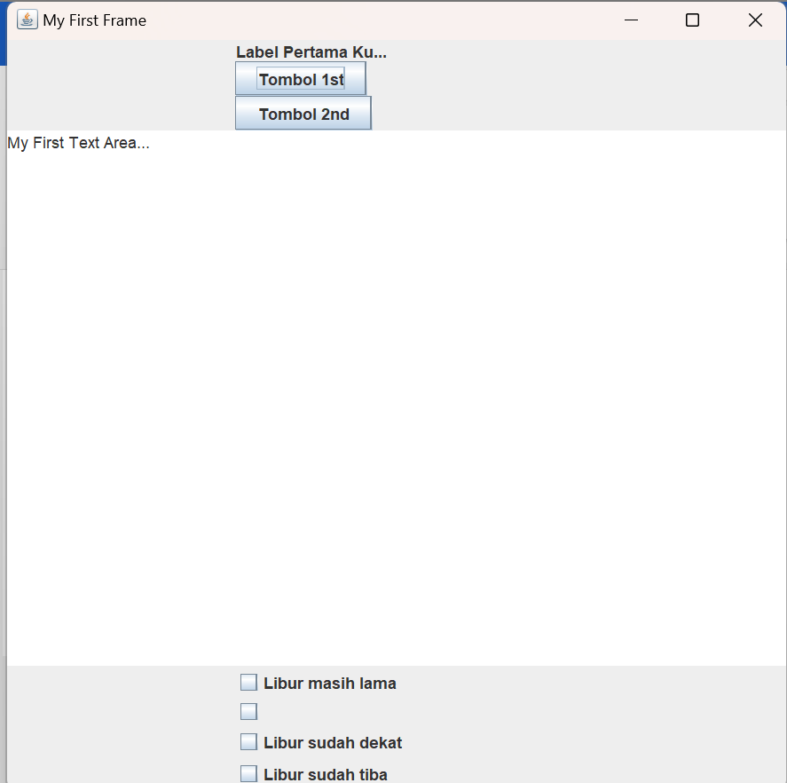

**C. Unguided**

Buatlah suatu tampilan antar muka yang unik dan bagus untuk sebuah program. Cukup tampilannya saja. Cari Ide program yang sederhana dan unik.

I. Membuat Tampilan UI Formulir

Contoh :

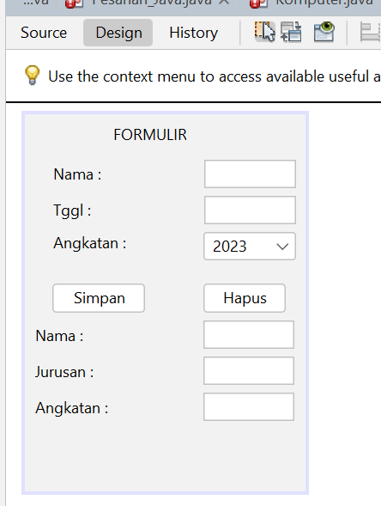

II.Buatlah Class Interface “Praktikum.java”

III. Hasil Tampilan

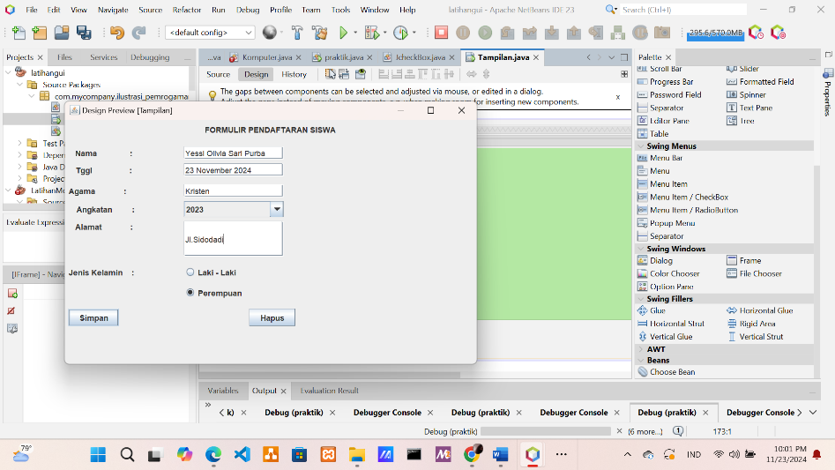

Penjelasan :

Dari contoh interface diatas, pada desain formulir pendaftaran siswa tersebut dijelaskan bahwa terdapat isian nama, tanggal, agama, angkatan, alamat, jenis kelamin yang dapat diisi oleh user, Serta terdapat pilihan menu simpan untuk menyimpan database formulir dan juga menu Hapus untuk menghapus database yang telah user inputkan.

IV. Source Kode

/*

* Click nbfs://nbhost/SystemFileSystem/Templates/Licenses/license-default.txt to change this license

* Click nbfs://nbhost/SystemFileSystem/Templates/GUIForms/JFrame.java to edit this template

*/

package com.mycompany.ilustrasi_pemrogaman_gui;

/**

*

* @author USER

*/

public class Tampilan extends javax.swing.JFrame {

/**

* Creates new form Tampilan

*/

public Tampilan() {

initComponents();

}

/**

* This method is called from within the constructor to initialize the form.

* WARNING: Do NOT modify this code. The content of this method is always

* regenerated by the Form Editor.

*/

@SuppressWarnings("unchecked")

// <editor-fold defaultstate="collapsed" desc="Generated Code">

private void initComponents() {

jToggleButton1 = new javax.swing.JToggleButton();

buttonGroup1 = new javax.swing.ButtonGroup();

jRadioButtonMenuItem1 = new javax.swing.JRadioButtonMenuItem();

jColorChooser1 = new javax.swing.JColorChooser();

jPopupMenu1 = new javax.swing.JPopupMenu();

jMenu1 = new javax.swing.JMenu();

jLabel1 = new javax.swing.JLabel();

jLabel2 = new javax.swing.JLabel();

jLabel3 = new javax.swing.JLabel();

jLabel4 = new javax.swing.JLabel();

jTextField4 = new javax.swing.JTextField();

angkatan = new javax.swing.JComboBox<>();

jButton1 = new javax.swing.JButton();

jToggleButton2 = new javax.swing.JToggleButton();

jLabel8 = new javax.swing.JLabel();

jTextField8 = new javax.swing.JTextField();

jLabel9 = new javax.swing.JLabel();

jTextField9 = new javax.swing.JTextField();

jLabel10 = new javax.swing.JLabel();

jRadioButton1 = new javax.swing.JRadioButton();

jRadioButton2 = new javax.swing.JRadioButton();

filler1 = new javax.swing.Box.Filler(new java.awt.Dimension(20, 0), new java.awt.Dimension(20, 0), new java.awt.Dimension(20, 32767));

jTextField10 = new javax.swing.JTextField();

jToggleButton1.setText("jToggleButton1");

jRadioButtonMenuItem1.setSelected(true);

jRadioButtonMenuItem1.setText("jRadioButtonMenuItem1");

jMenu1.setText("jMenu1");

setDefaultCloseOperation(javax.swing.WindowConstants.EXIT_ON_CLOSE);

jLabel1.setText("FORMULIR PENDAFTARAN SISWA");

jLabel2.setText("Nama : ");

jLabel3.setText("Tggl : ");

jLabel4.setText("Angkatan :");

angkatan.setModel(new javax.swing.DefaultComboBoxModel<>(new String[] { "2023", "2026", "2021", "2024" }));

jButton1.setText("Simpan");

jToggleButton2.setText("Hapus");

jToggleButton2.addActionListener(new java.awt.event.ActionListener() {

public void actionPerformed(java.awt.event.ActionEvent evt) {

jToggleButton2ActionPerformed(evt);

}

});

jLabel8.setText("Agama :");

jLabel9.setText("Alamat :");

jLabel10.setText("Jenis Kelamin :");

jRadioButton1.setText("Laki - Laki");

jRadioButton2.setText("Perempuan");

jRadioButton2.addActionListener(new java.awt.event.ActionListener() {

public void actionPerformed(java.awt.event.ActionEvent evt) {

jRadioButton2ActionPerformed(evt);

}

});

javax.swing.GroupLayout layout = new javax.swing.GroupLayout(getContentPane());

getContentPane().setLayout(layout);

layout.setHorizontalGroup(

layout.createParallelGroup(javax.swing.GroupLayout.Alignment.LEADING)

.addGroup(layout.createSequentialGroup()

.addGap(215, 215, 215)

.addComponent(jLabel1)

.addContainerGap(javax.swing.GroupLayout.DEFAULT_SIZE, Short.MAX_VALUE))

.addGroup(javax.swing.GroupLayout.Alignment.TRAILING, layout.createSequentialGroup()

.addContainerGap(javax.swing.GroupLayout.DEFAULT_SIZE, Short.MAX_VALUE)

.addGroup(layout.createParallelGroup(javax.swing.GroupLayout.Alignment.LEADING)

.addGroup(javax.swing.GroupLayout.Alignment.TRAILING, layout.createSequentialGroup()

.addGroup(layout.createParallelGroup(javax.swing.GroupLayout.Alignment.TRAILING)

.addComponent(jLabel3)

.addComponent(jLabel2)

.addGroup(layout.createSequentialGroup()

.addComponent(jLabel9)

.addGap(2, 2, 2))

.addGroup(layout.createParallelGroup(javax.swing.GroupLayout.Alignment.LEADING)

.addComponent(jButton1)

.addComponent(jLabel10))

.addComponent(jLabel4)

.addComponent(jLabel8, javax.swing.GroupLayout.Alignment.LEADING))

.addGroup(layout.createParallelGroup(javax.swing.GroupLayout.Alignment.LEADING)

.addGroup(layout.createSequentialGroup()

.addGap(76, 76, 76)

.addGroup(layout.createParallelGroup(javax.swing.GroupLayout.Alignment.LEADING)

.addComponent(jRadioButton1)

.addGroup(layout.createParallelGroup(javax.swing.GroupLayout.Alignment.TRAILING)

.addComponent(jTextField10, javax.swing.GroupLayout.PREFERRED_SIZE, 153, javax.swing.GroupLayout.PREFERRED_SIZE)

.addComponent(jTextField8, javax.swing.GroupLayout.PREFERRED_SIZE, 153, javax.swing.GroupLayout.PREFERRED_SIZE)

.addComponent(jTextField4, javax.swing.GroupLayout.PREFERRED_SIZE, 153, javax.swing.GroupLayout.PREFERRED_SIZE)

.addComponent(angkatan, javax.swing.GroupLayout.PREFERRED_SIZE, 153, javax.swing.GroupLayout.PREFERRED_SIZE)

.addComponent(jTextField9, javax.swing.GroupLayout.PREFERRED_SIZE, 153, javax.swing.GroupLayout.PREFERRED_SIZE))

.addComponent(jRadioButton2)))

.addGroup(layout.createSequentialGroup()

.addGap(176, 176, 176)

.addComponent(jToggleButton2)))

.addGap(431, 431, 431))

.addComponent(filler1, javax.swing.GroupLayout.Alignment.TRAILING, javax.swing.GroupLayout.PREFERRED_SIZE, 129, javax.swing.GroupLayout.PREFERRED_SIZE))

.addGap(297, 297, 297))

);

layout.setVerticalGroup(

layout.createParallelGroup(javax.swing.GroupLayout.Alignment.LEADING)

.addGroup(layout.createSequentialGroup()

.addContainerGap()

.addComponent(jLabel1)

.addPreferredGap(javax.swing.LayoutStyle.ComponentPlacement.RELATED)

.addComponent(filler1, javax.swing.GroupLayout.PREFERRED_SIZE, 0, javax.swing.GroupLayout.PREFERRED_SIZE)

.addGap(12, 12, 12)

.addGroup(layout.createParallelGroup(javax.swing.GroupLayout.Alignment.BASELINE)

.addComponent(jLabel2)

.addComponent(jTextField10, javax.swing.GroupLayout.PREFERRED_SIZE, javax.swing.GroupLayout.DEFAULT_SIZE, javax.swing.GroupLayout.PREFERRED_SIZE))

.addPreferredGap(javax.swing.LayoutStyle.ComponentPlacement.RELATED)

.addGroup(layout.createParallelGroup(javax.swing.GroupLayout.Alignment.BASELINE)

.addComponent(jLabel3)

.addComponent(jTextField8, javax.swing.GroupLayout.PREFERRED_SIZE, javax.swing.GroupLayout.DEFAULT_SIZE, javax.swing.GroupLayout.PREFERRED_SIZE))

.addGap(12, 12, 12)

.addGroup(layout.createParallelGroup(javax.swing.GroupLayout.Alignment.BASELINE)

.addComponent(jTextField4, javax.swing.GroupLayout.PREFERRED_SIZE, javax.swing.GroupLayout.DEFAULT_SIZE, javax.swing.GroupLayout.PREFERRED_SIZE)

.addComponent(jLabel8))

.addPreferredGap(javax.swing.LayoutStyle.ComponentPlacement.RELATED)

.addGroup(layout.createParallelGroup(javax.swing.GroupLayout.Alignment.BASELINE)

.addComponent(angkatan, javax.swing.GroupLayout.PREFERRED_SIZE, javax.swing.GroupLayout.DEFAULT_SIZE, javax.swing.GroupLayout.PREFERRED_SIZE)

.addComponent(jLabel4))

.addPreferredGap(javax.swing.LayoutStyle.ComponentPlacement.RELATED)

.addGroup(layout.createParallelGroup(javax.swing.GroupLayout.Alignment.LEADING)

.addComponent(jTextField9, javax.swing.GroupLayout.PREFERRED_SIZE, 54, javax.swing.GroupLayout.PREFERRED_SIZE)

.addComponent(jLabel9))

.addPreferredGap(javax.swing.LayoutStyle.ComponentPlacement.UNRELATED)

.addGroup(layout.createParallelGroup(javax.swing.GroupLayout.Alignment.BASELINE)

.addComponent(jRadioButton1)

.addComponent(jLabel10))

.addPreferredGap(javax.swing.LayoutStyle.ComponentPlacement.RELATED)

.addComponent(jRadioButton2)

.addPreferredGap(javax.swing.LayoutStyle.ComponentPlacement.UNRELATED)

.addGroup(layout.createParallelGroup(javax.swing.GroupLayout.Alignment.BASELINE)

.addComponent(jButton1)

.addComponent(jToggleButton2))

.addContainerGap(58, Short.MAX_VALUE))

);

pack();

}// </editor-fold>

private void jToggleButton2ActionPerformed(java.awt.event.ActionEvent evt) {

// TODO add your handling code here:

}

private void jRadioButton2ActionPerformed(java.awt.event.ActionEvent evt) {

// TODO add your handling code here:

}

/**

* @param args the command line arguments

*/

public static void main(String args[]) {

/* Set the Nimbus look and feel */

//<editor-fold defaultstate="collapsed" desc=" Look and feel setting code (optional) ">

/* If Nimbus (introduced in Java SE 6) is not available, stay with the default look and feel.

* For details see http://download.oracle.com/javase/tutorial/uiswing/lookandfeel/plaf.html

*/

try {

for (javax.swing.UIManager.LookAndFeelInfo info : javax.swing.UIManager.getInstalledLookAndFeels()) {

if ("Nimbus".equals(info.getName())) {

javax.swing.UIManager.setLookAndFeel(info.getClassName());

break;

}

}

} catch (ClassNotFoundException ex) {

java.util.logging.Logger.getLogger(Tampilan.class.getName()).log(java.util.logging.Level.SEVERE, null, ex);

} catch (InstantiationException ex) {

java.util.logging.Logger.getLogger(Tampilan.class.getName()).log(java.util.logging.Level.SEVERE, null, ex);

} catch (IllegalAccessException ex) {

java.util.logging.Logger.getLogger(Tampilan.class.getName()).log(java.util.logging.Level.SEVERE, null, ex);

} catch (javax.swing.UnsupportedLookAndFeelException ex) {

java.util.logging.Logger.getLogger(Tampilan.class.getName()).log(java.util.logging.Level.SEVERE, null, ex);

}

//</editor-fold>

/* Create and display the form */

java.awt.EventQueue.invokeLater(new Runnable() {

public void run() {

new Tampilan().setVisible(true);

}

});

}

// Variables declaration - do not modify

private javax.swing.JComboBox<String> angkatan;

private javax.swing.ButtonGroup buttonGroup1;

private javax.swing.Box.Filler filler1;

private javax.swing.JButton jButton1;

private javax.swing.JColorChooser jColorChooser1;

private javax.swing.JLabel jLabel1;

private javax.swing.JLabel jLabel10;

private javax.swing.JLabel jLabel2;

private javax.swing.JLabel jLabel3;

private javax.swing.JLabel jLabel4;

private javax.swing.JLabel jLabel8;

private javax.swing.JLabel jLabel9;

private javax.swing.JMenu jMenu1;

private javax.swing.JPopupMenu jPopupMenu1;

private javax.swing.JRadioButton jRadioButton1;

private javax.swing.JRadioButton jRadioButton2;

private javax.swing.JRadioButtonMenuItem jRadioButtonMenuItem1;

private javax.swing.JTextField jTextField10;

private javax.swing.JTextField jTextField4;

private javax.swing.JTextField jTextField8;

private javax.swing.JTextField jTextField9;

private javax.swing.JToggleButton jToggleButton1;

private javax.swing.JToggleButton jToggleButton2;

// End of variables declaration

}